ANALYSIS OF OUR ERASMUS+ MOBILITY TO BRNO WITH THE STUDENTS IN APRIL 2022
Q1 How did you like your stay at 10-Z hostel?
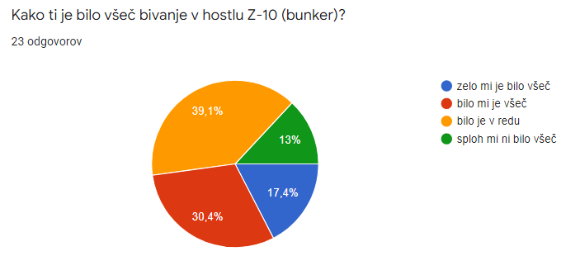
I liked it very much
I liked it
It was OK
I didn't like it at all
3 students didn't like the stay at all, 9 said it was OK, 7 liked it, 4 liked it very much

Q2 Point out the positive or negative things about your stay at 10-Z.
The majority of students said that it was an interesting and memorable experience. The food (the dinner) was the most negative thing because they aren't used to such salads. Some students liked the food though. Some students complained about the cold and they didn't expect the furniture to be so old. Some students were shocked by the extra equipment in the rooms (fake blood, dentist's equipment...)

Q3 How did you like the museums (Antropos, VIDA, Moravian National museum...)?
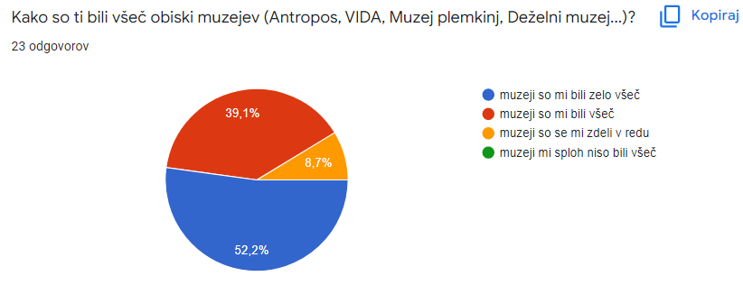
very much
I liked them
They were Ok
I didn't like them
12 students liked the museums very much, 9 students liked the museums and 2 students said the museums were OK.
Q4 What would you point out in your visit to the different museums?
House of experiments VIDA was their top choice, followed by Antropos. The students said that they liked all the museums and wished they could have stayed in Antropos and VIDA for a longer period of time. Some wish to visit them again. Some students pointed out that they would prefer the guided tour in the museums were in English only as it would be a lot more interesting for them. Some students pointed out that the museums were very interesting as they haven't seen such museums in Slovenia. They said that they learned and saw a lot and are very thankful for the experience.

Q5 How did you like the excursion and the train ride to Prague?
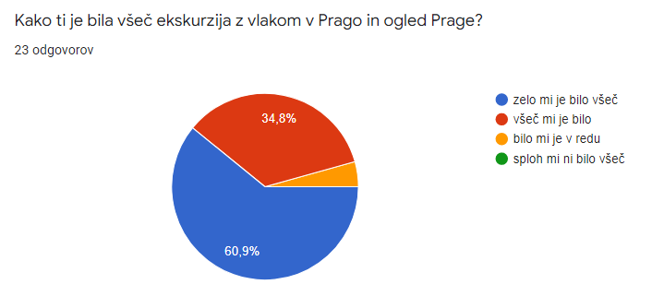
Very much
I liked it
It was OK
I didn't like it at all

14 students liked it very much, 8 students liked it, 1 student said it was OK

Q6 What would you point out here?
The majority of students said the train was very modern and comfortable. They were impressed by the tablet computers attached to the seats. They also liked the food on the train. A lot of students were impressed by the train, tram and underground train rides as it was their first time riding with such means of transport. In Prague they were mostly impressed by Charles bridge, Vltava and St. Vitus's cathedral. One students expressed a wish to visit Prague in a time when there wouldn't be so many tourists as it was too crowded.

Q7 How did you like your visit and the lessons at Armenska primary school?
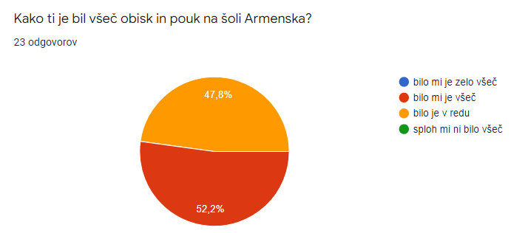
I liked it.
It was OK.
12 students liked them and 11 said it was OK.

Q8 What would you point out here?
Almost all students expressed a regret that they couldn't attend lessons with their peers but they liked the lessons with the younger pupils. The students were impressed by the size of the classrooms and the posters on the walls of the classrooms. They liked the planting of the tree and the games they played. The swimming pool and the swimming practice were rated very high.

Q9 Children need 5 meals a day. How did you find the selection of the food?
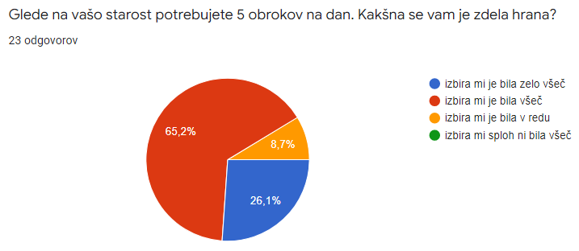
very much
I liked it
It was OK
I didn't like it at all.
15 students said they liked the selection very much, 6 students said they liked the selection, 2 students said the selection was OK

Q10 What food didn't you like?
Most children didn't like the salad at 10-Z and the salad on the train. Some didn't like the food in the school and some found the food in KFC too spicy.

Q11 How did you find the amount of the food?
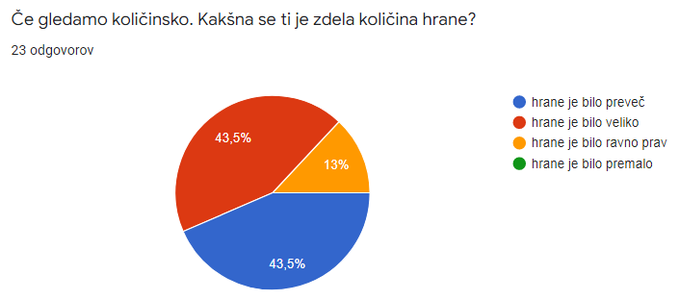
There was too much food
There was a lot of food.
The amount of food was just right.
There wasn't enough food.
3 students said the amount was just right, 10 students said there was a lot of food, 10 students said there was too much food.

Q12 Erasmus+ mobility is meant for educational purposes but there was some free time during your stay in The Czech Republic. Was there enough free time? What would you do if you had more free time?
The majority of students said the amount of free time was OK. They spent it socializing, playing cards, talking to their friends, playing board games, buying souvenirs. A few students said that they didn't have enough free time, especially for shopping or hanging out in the evenings.

Q13 What did you gain with this Erasmus+ mobility?
All the students said that they gained new experience, knowledge, friendships. They will cherish these things forever. Some students realized that sometimes we are prejudiced without a justifiable cause and this experience changed their mind. A lot of students are really thankful for the opportunity to travel and try out new things.

Q14 What is your most memorable experience in this mobility?
Most students pointed out the excursion to Prague, the ride with the underground train and the modern train. VIDA, Brno ZOO and 10-Z hostel made a great impression on most students as well. One student said that the planetarium was unforgettable as it was her first time experiencing such a thing.

Q15 Were there any activities, experiences, etc. that you didn't like?
For most students there were no unpleasant things to point out. Some students pointed out their stay at 10-Z hostel because it was too cold.

